

Grandstream Networks， Inc.

GWN 700x Dynamic Routing

**User Guide v1.0**

# Table of Contents



OSPF 3

Dynamic Routing Learning 3

*Configuration 3*

*Show OSPF Route learning 5*

*Neighbor Info 5*

*Test Network Connectivity 6*

Import Direct Routing 6

*Configuration 7*

*Show OSPF Route learning 9*

*Test Network Connectivity 10*

RIP 11

Dynamic Routing Learning 11

*Configuration 11*

*Neighbour Info 12*

*Test Network Connectivity 13*

Import Direct Routing 13

*Configuration 14*

*Test Network Connectivity (PC1 ping PC2) 15*

BGP 16

Dynamic Routing Learning 16

*Configuration 16*

*Peer Info 17*

*Test Network Connectivity*（*PC1 ping PC2*） *18*

Import Direct Routing 18

*Configuration 18*

*Show BGP Route learning 20*

*Test Network Connectivity (PC1 ping PC2) 21*

# OSPF



### Dynamic Routing Learning

The example of networking scenario:

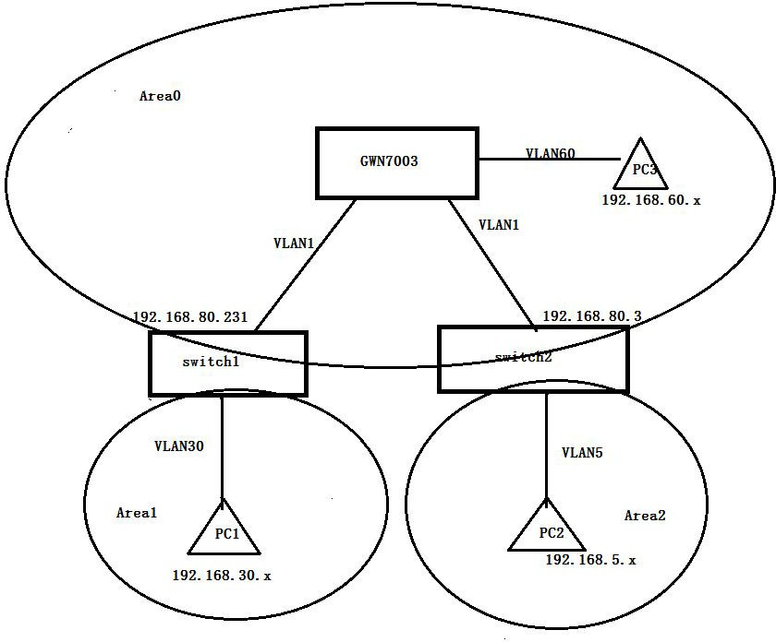

### Configuration

###### *Global Settings*

1. Navigate to Routing→OSPF→Global Settings
2. Enable "OSPF" and fill in the Router ID
3. Click Save

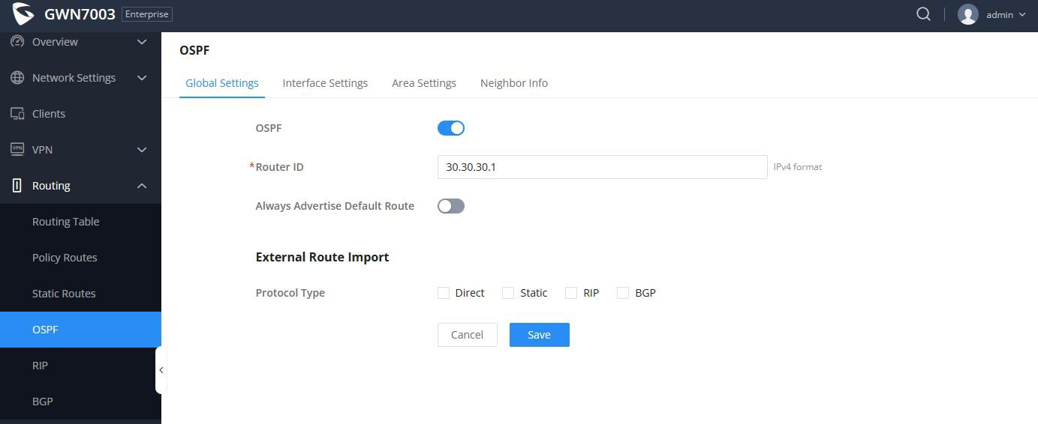

###### *Interface Settings*

On this tab, users can add interfaces (e.g VLANs) or enable/disable them, and perform related configurations based on the interface. It mainly includes area ID, Hello interval, Dead interval, overhead

value, etc.



1. Navigate to Routing->OSPF->Interface Settings
2. Users can add interfaces (e.g VLANs) or enable/disable them, and perform related configurations based on the interface. It mainly includes area ID, Hello interval, Dead interval, overhead value, etc.
3. Click "Save" to apply

***Note:***

If global OSPF is not enabled, the configuration will not take effect.

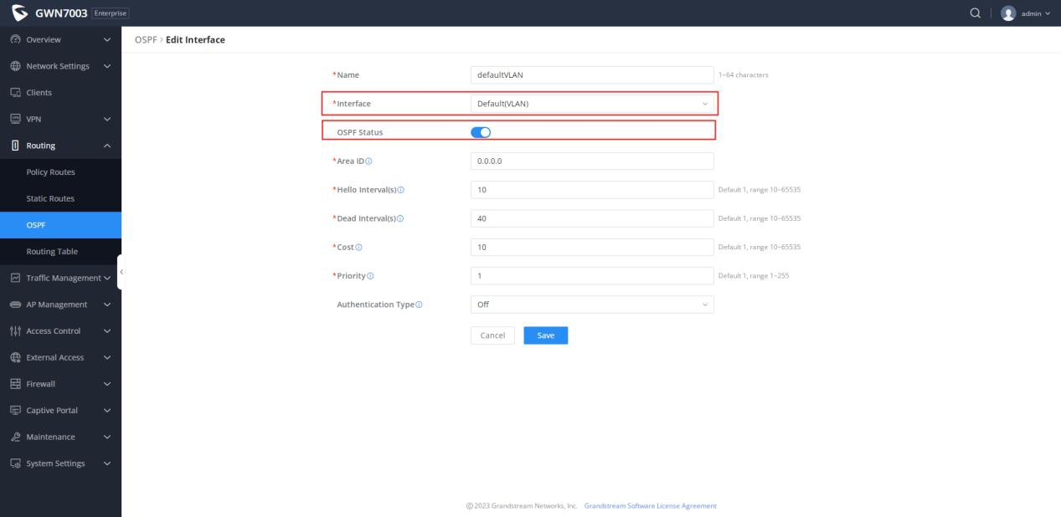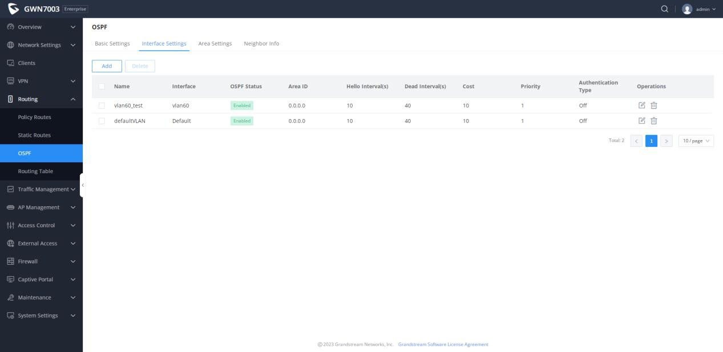

At the same time, OSPF and interface information should also be configured on the two switches on the LAC side

***Note***: *Both VLAN30 on Switch1 and VLAN4 on Switch2 need to configure the interface and enable OSPF*

###### *Area Settings*



1. Navigate to Routing->OSPF->Area Settings
2. The area ID configured in the interface Settings will be displayed synchronously in this section, and the area type can be configured.

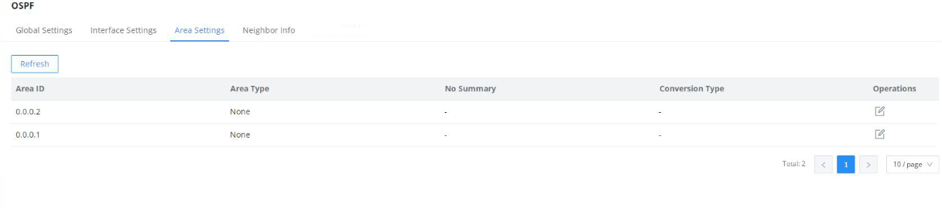

**Show OSPF Route learning**

1. Navigate to Routing->Routing Table
2. After the configuration is complete, check the routing table. It can be seen that the VLAN5 and VLAN30 routes under the two switches have been learned, and the next hop is the IP address of the corresponding switch, respectively

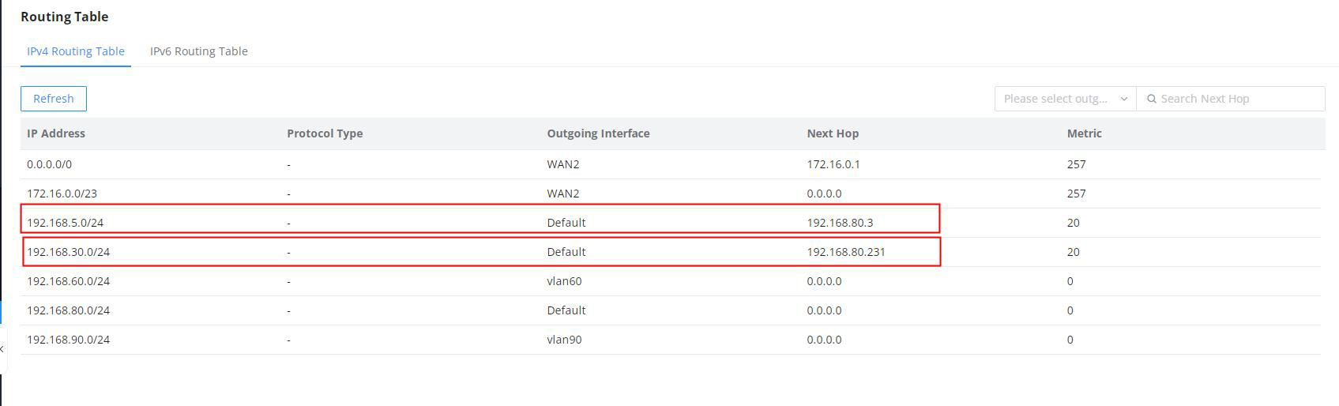

1. At the same time, you can go to the routing table of the switch to view it, and the switch can also learn VLAN 60 of the router

#### Neighbor Info

All neighbor information currently learned can be viewed in the neighbor table

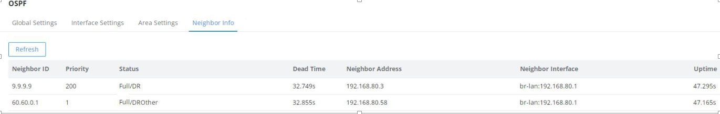

#### Test Network Connectivity



According to the above networking scenario, PC1 and PC2 and PC3 can ping each other, and the results are as follows:

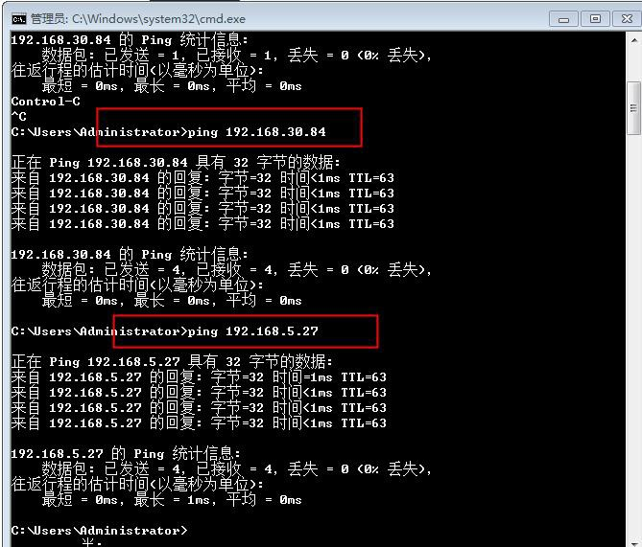

### Import Direct Routing

**The example of networking scenario**

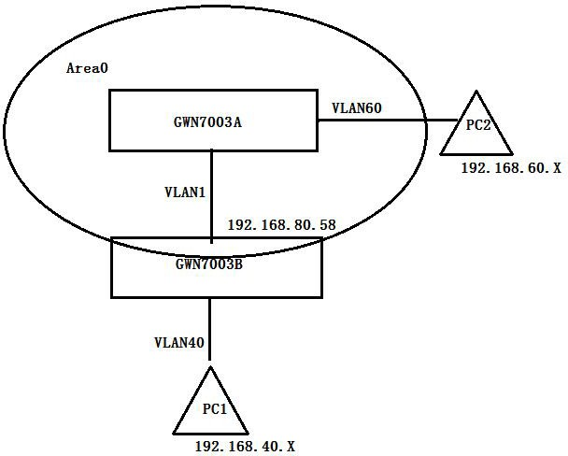

#### Configuration



##### GWN7003A is configured as follows:

1. Enable OSPF and configure the Router ID.
2. Add interfaces: Add Default (vlan) and VLAN60 interfaces, and OSPF is enabled.

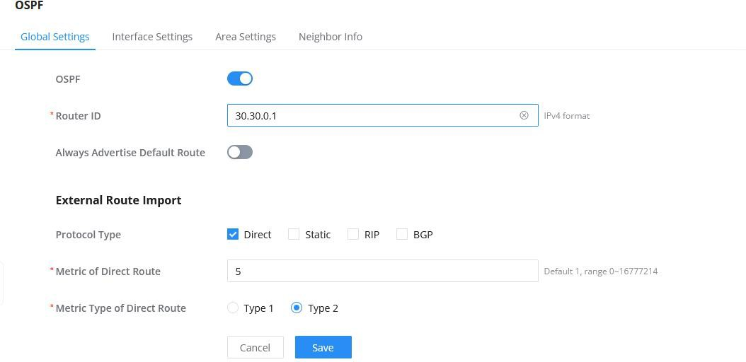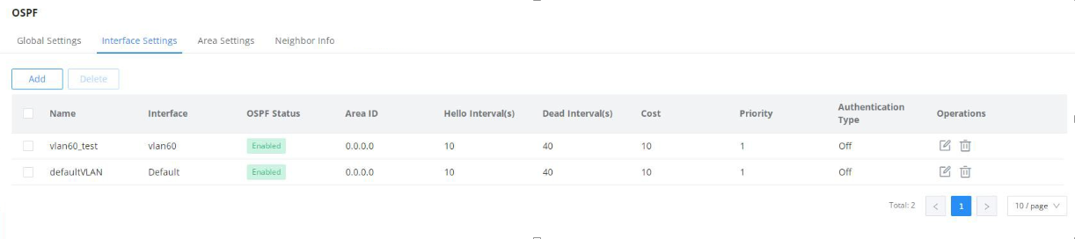

##### GWN7003B is configured as follows:

1. Enable OSPF and configure RouterID (make sure it is unique)
2. Enable direct routing
3. Add interface: Add WAN interface and OSPF is enabled;

***Note***: *Because direct routing is enabled, VLAN40 does not need to configure interfaces*

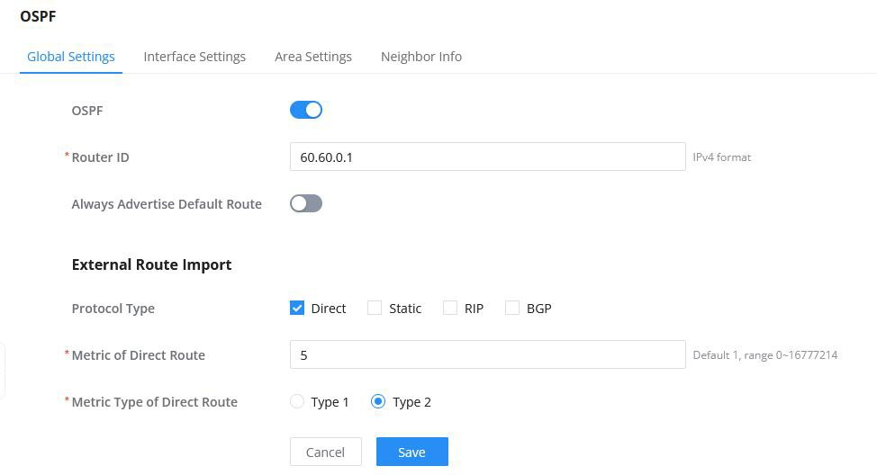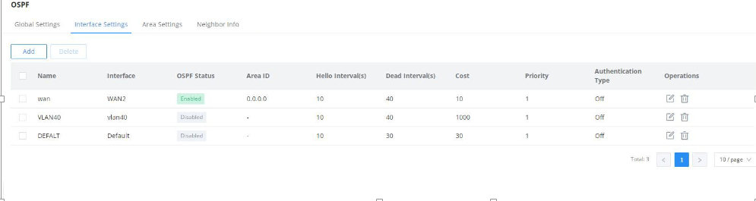

（See the previous scenario for detailed configuration steps）

##### If you want to access devices under VLAN40,GWN7003B needs to configure firewall rules：

1. Firewall->Traffic Rules->Forwarding Rules Add a forwarding rule

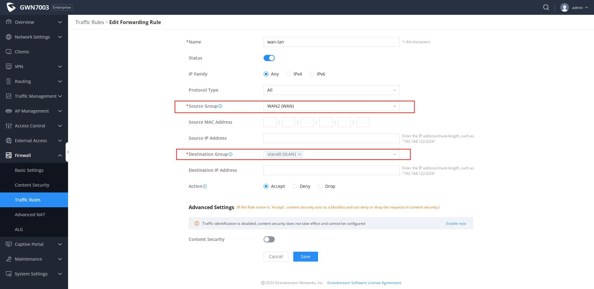

#### Show OSPF Route learning

Navigate to **Routing Table**, OSPF routing learning results can be viewed

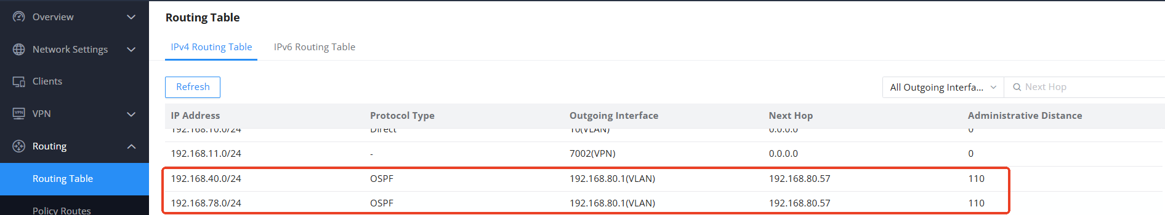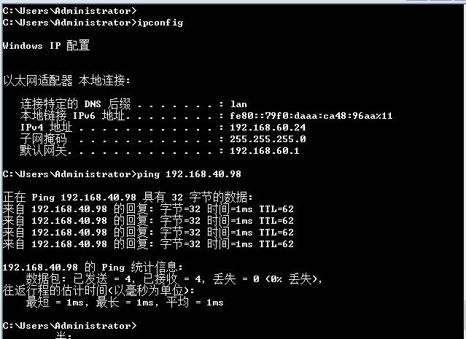

**Test Network Connectivity**

# RIP



### Dynamic Routing Learning

**The example of networking scenario**

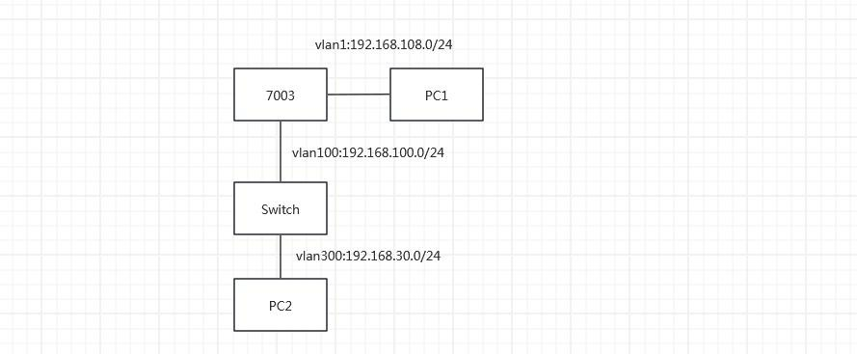

### Configuration

###### *Global Settings*

Users can configure the RIPv1 or RIPv2 global parameters like enabling RIP, RIP Distance, and Timers (Update Timer, Invalid Timer and Garbage Collection Timer) as well as External Route Import (Direct, Static, OSPF and BGP).

To configure RIP, please navigate to **Routing** → **RIP**→**Global Settings**:

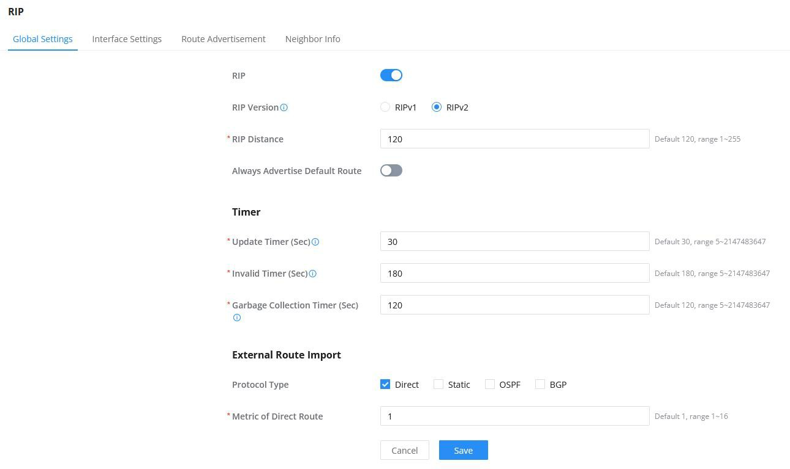

###### *Interface Settings*



The Interface Settings tab allows the user to Add/Delete/Edit interfaces (e.g VLANs), enable the RIP on the interface and perform related configurations.

***Note:***

If global RIP is not enabled, the configuration will not take effect.

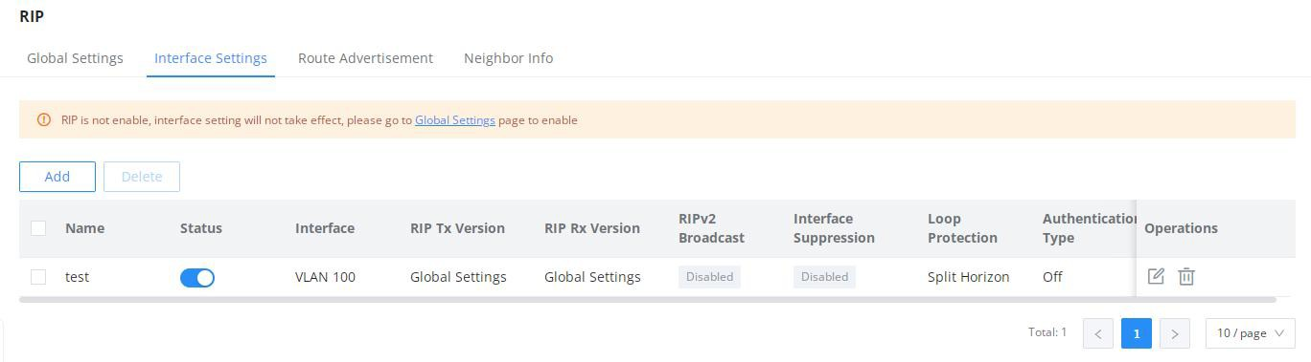

###### *Route Advertisements*

RIP route advertisement involves broadcasting routing information to neighboring routers, providing details about network destinations and associated metrics, facilitating dynamic route updates in a network. RIP advertises routes periodically to maintain an updated routing table.

The advertised routes will be shown on this tab, the user has the option to add a route advertisement by clicking on “Add” button.

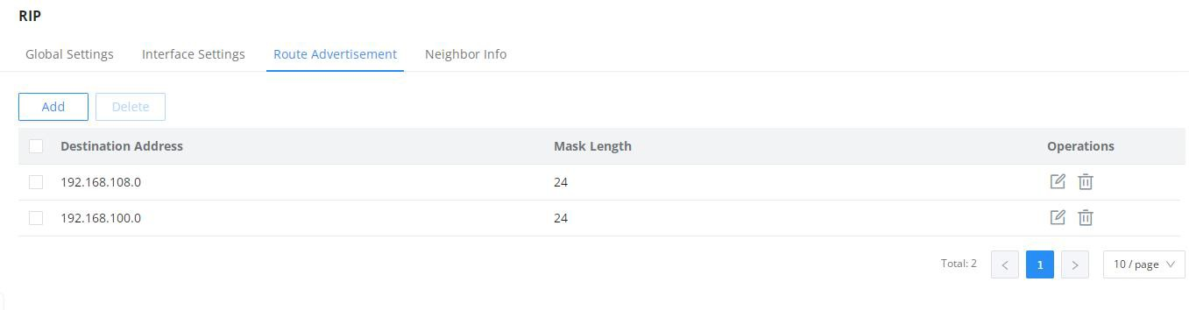

### Neighbour Info

This page displays the neighbor information table under the current RIP process.

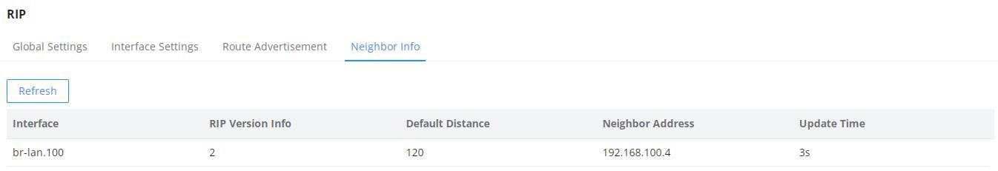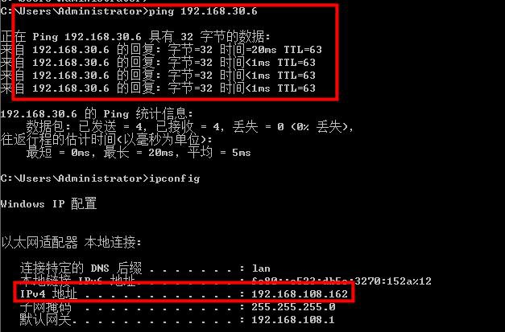

**Test Network Connectivity**

### Import Direct Routing

## The example of networking scenario

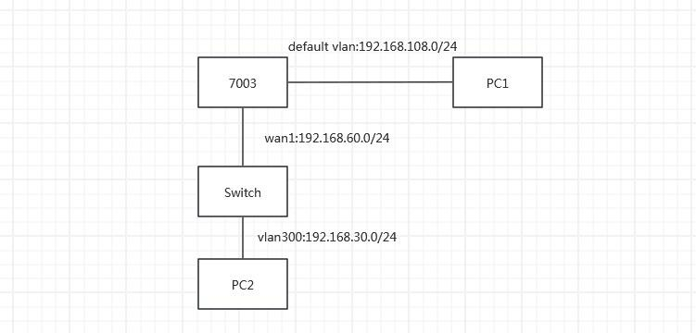

### Configuration



##### GWN7003 is configured as follows:

1. Enable RIP
2. Enable External Route Import and Protocol Type Select Direct
3. Add interface: Add WAN interface
4. Add Route Advertisement

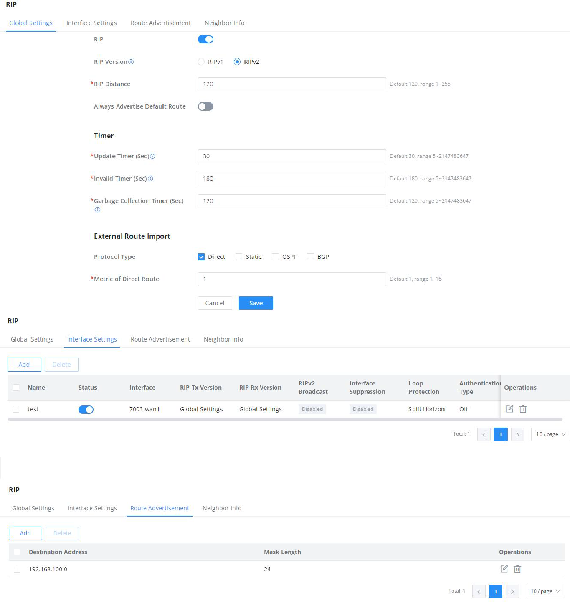

If PC2 want to access devices under PC1,GWN7003 needs to configure firewall rules：

1. Firewall->Traffic Rules->Forwarding Rules. Add a forwarding rule

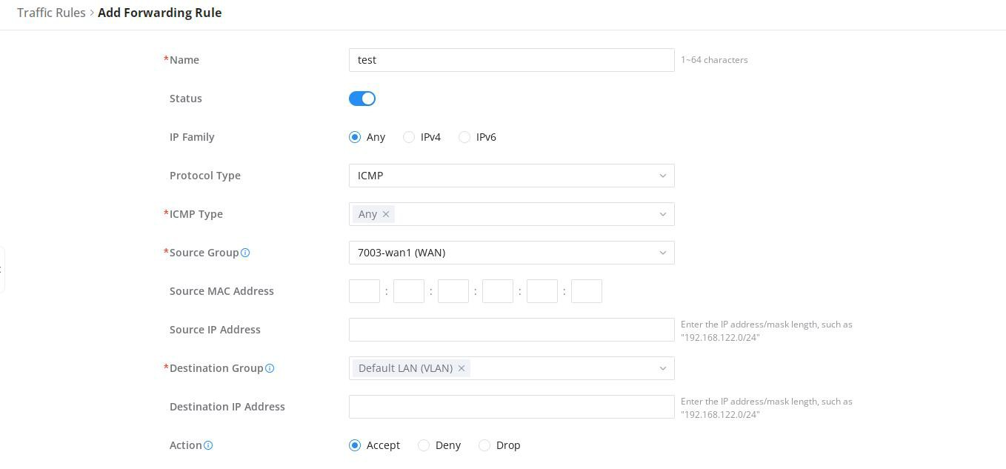

### Test Network Connectivity (PC1 ping PC2)

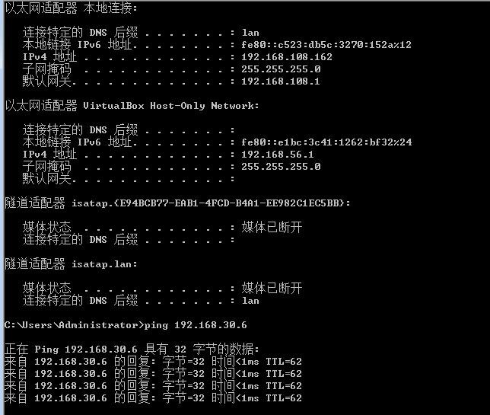

# BGP



### Dynamic Routing Learning

**The example of networking scenario**

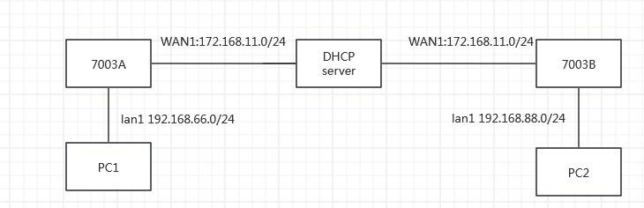

### Configuration

###### *Global Settings*

On the Global Settings tab, the users can enable BGP protocol and the set the AS (Autonomous System) and the Router ID, as well as importing external routes: Direct, Static, OSPF and RIP.

To configure BGP, please navigate to **Routing→BGP→Global Settings**:

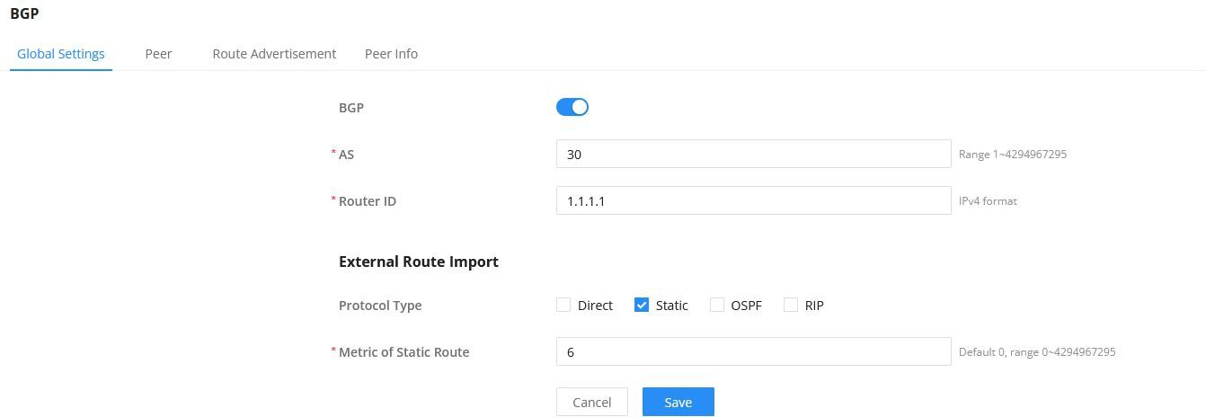

***Note:***

If you want to configure IBGP neighbors, then the AS numbers of two 7003 are the same. If you want to configure EBGP neighbors, then the AS numbers of two 7003 are different

###### *Peer*

When using the BGP protocol, a peer relationship must be established to exchange BGP messages between devices. The user can add a peer by clicking the “ Add ” button or modify the previously added peers and perform related configurations.

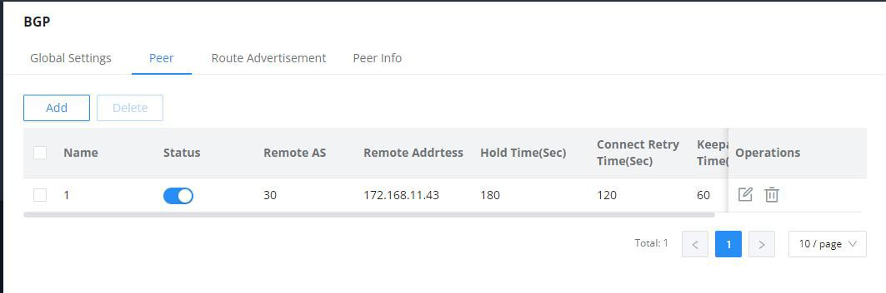

***Note:***

1. If global BGP is not enabled, the configuration will not take effect.
2. ‘Remote AS’, please enter the AS of the remote device

###### *Route Advertisement*

This page allows the user to set the subnet segment address to be advertised using the BGP protocol. To add more, click the “+” icon.

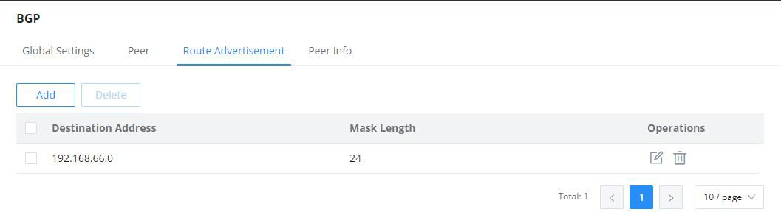

### Peer Info

On this page, the users can find the peer status information displayed with BGP Version Info, Peer Address, Peer AS, Status and Uptime.

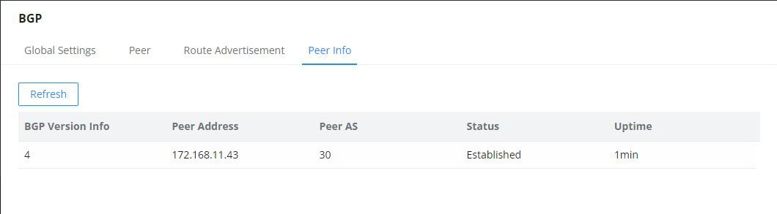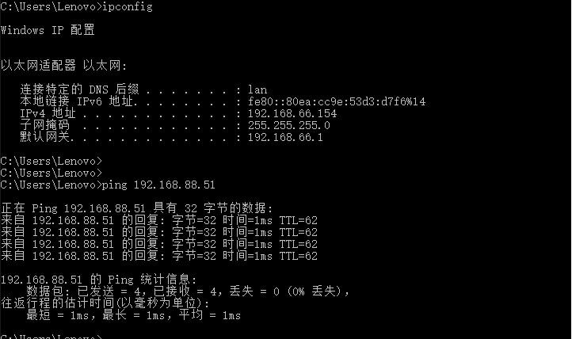

**Test Network Connectivity（PC1 ping PC2）**

note：

If you want to access devices under VLAN,GWN7003A and GWN7003B needs to configure firewall rules：

1. Firewall->Traffic Rules->Forwarding Rules. Add a forwarding rule from wan –to-lan



### Import Direct Routing

## The example of networking scenario



### Configuration

##### GWN7003 is configured as follows:

1. Enable BGP and configure AS and RouterID (make sure it is unique)
2. Enable direct routing
3. Add peer: configure remote AS and and remote address, BGP status is enabled

***Note:***

If you want to configure IBGP neighbors, then the AS numbers of two 7003 are the same. If you want to

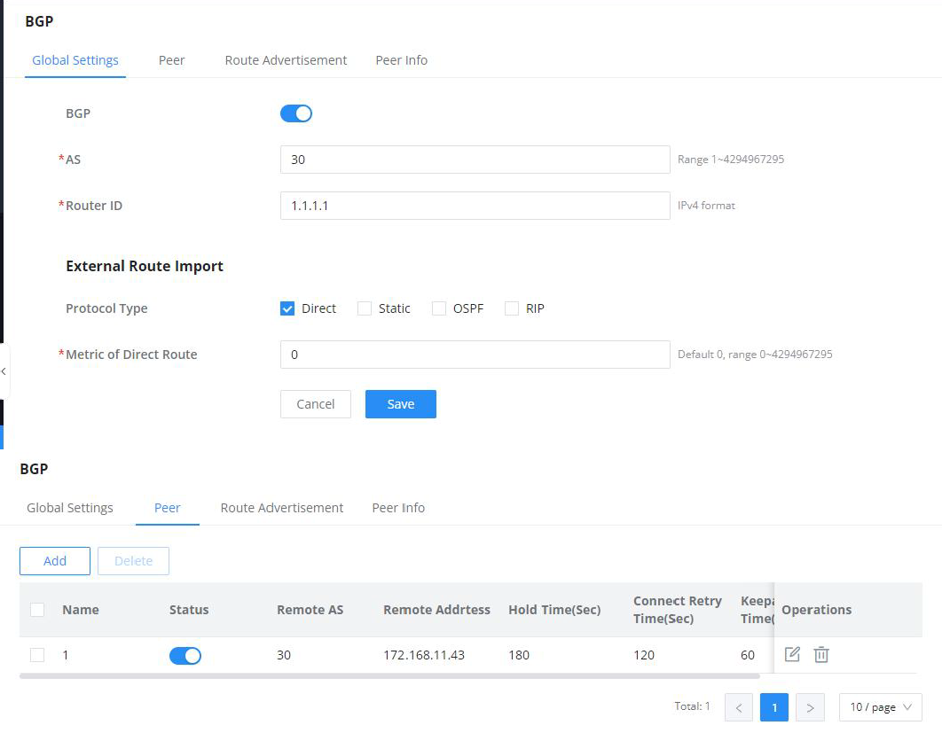

configure EBGP neighbors, then the AS numbers of two 7003 are different



### Show BGP Route learning

Navigate to Routing Table, BGP routing learning results can be viewed

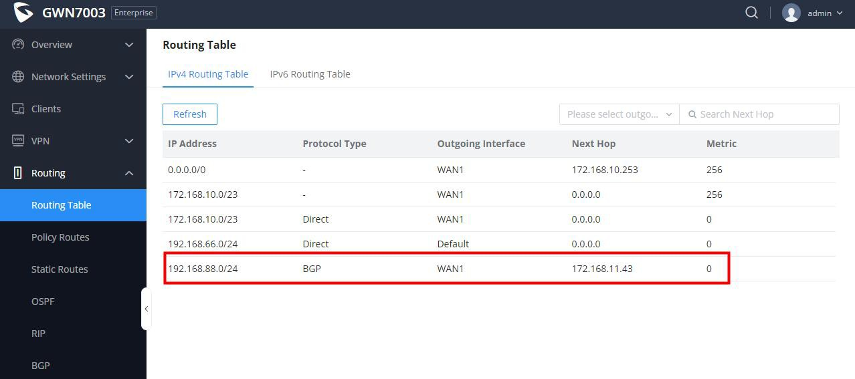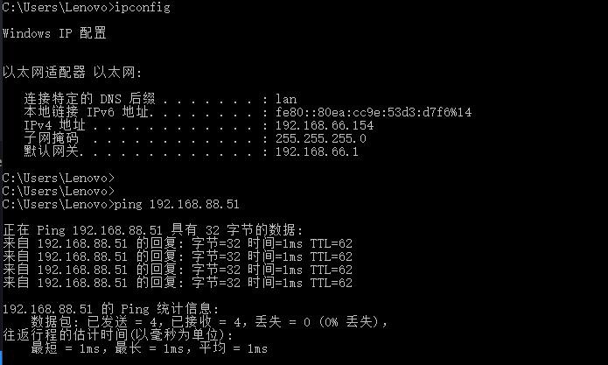

**Test Network Connectivity (PC1 ping PC2)**